**Consulta Spring Data**

Estimados buen día

En adjunto les paso unos print de pantalla del codigo con el código visto en la clase. Me esta dando error y no lo logro interpretar.

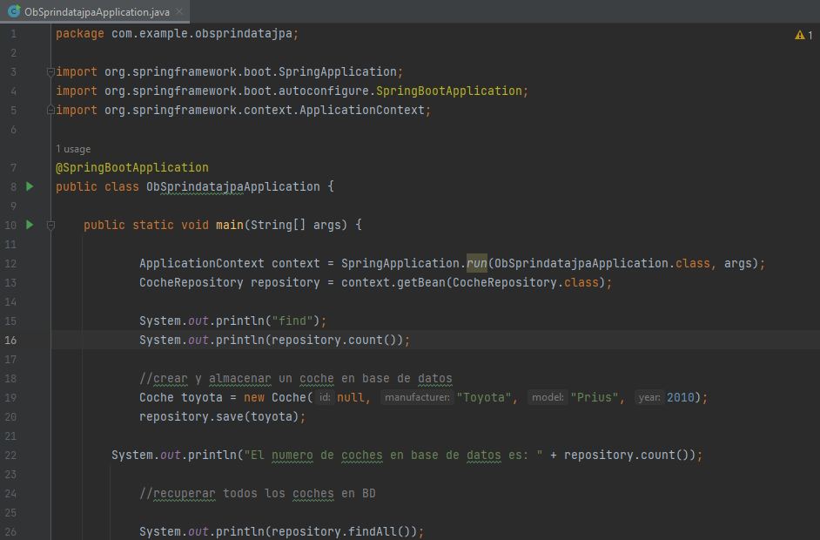

No muestra problemas pero si advertencias

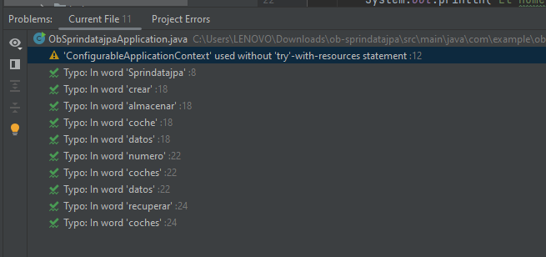

Y cuando ejecuto el main (Resalto algunas líneas con mensajes que estimo son el error línea 12 y 16 de ObSprindatajpaApplication.java )

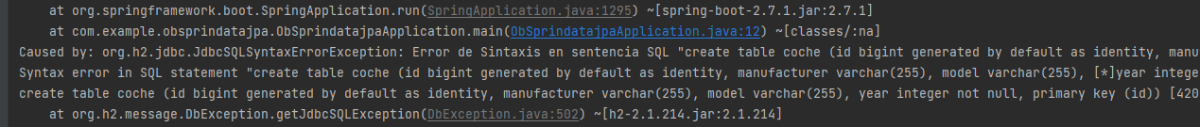

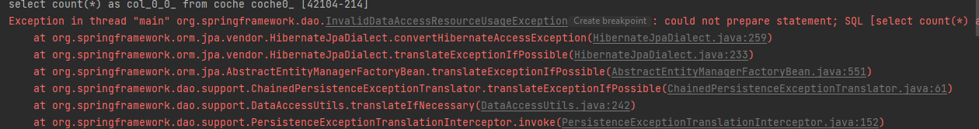

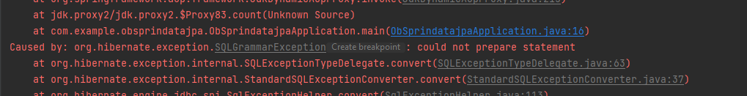

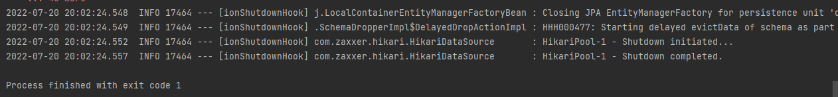

Copio la salida completa

C:\Users\LENOVO\jdk\jdk-18.0.1.1\bin\java.exe "-javaagent:C:\Program Files\JetBrains\IntelliJ IDEA Community Edition 2022.1.1\lib\idea_rt.jar=49461:C:\Program Files\JetBrains\IntelliJ IDEA Community Edition 2022.1.1\bin" -Dfile.encoding=UTF-8 -classpath C:\Users\LENOVO\Downloads\ob-sprindatajpa\target\classes;C:\Users\LENOVO\.m2\repository\org\springframework\boot\spring-boot-starter-data-jpa\2.7.1\spring-boot-starter-data-jpa-2.7.1.jar;C:\Users\LENOVO\.m2\repository\org\springframework\boot\spring-boot-starter-aop\2.7.1\spring-boot-starter-aop-2.7.1.jar;C:\Users\LENOVO\.m2\repository\org\springframework\spring-aop\5.3.21\spring-aop-5.3.21.jar;C:\Users\LENOVO\.m2\repository\org\aspectj\aspectjweaver\1.9.7\aspectjweaver-1.9.7.jar;C:\Users\LENOVO\.m2\repository\org\springframework\boot\spring-boot-starter-jdbc\2.7.1\spring-boot-starter-jdbc-2.7.1.jar;C:\Users\LENOVO\.m2\repository\com\zaxxer\HikariCP\4.0.3\HikariCP-4.0.3.jar;C:\Users\LENOVO\.m2\repository\org\springframework\spring-jdbc\5.3.21\spring-jdbc-5.3.21.jar;C:\Users\LENOVO\.m2\repository\jakarta\transaction\jakarta.transaction-api\1.3.3\jakarta.transaction-api-1.3.3.jar;C:\Users\LENOVO\.m2\repository\jakarta\persistence\jakarta.persistence-api\2.2.3\jakarta.persistence-api-2.2.3.jar;C:\Users\LENOVO\.m2\repository\org\hibernate\hibernate-core\5.6.9.Final\hibernate-core-5.6.9.Final.jar;C:\Users\LENOVO\.m2\repository\org\jboss\logging\jboss-logging\3.4.3.Final\jboss-logging-3.4.3.Final.jar;C:\Users\LENOVO\.m2\repository\net\bytebuddy\byte-buddy\1.12.11\byte-buddy-1.12.11.jar;C:\Users\LENOVO\.m2\repository\antlr\antlr\2.7.7\antlr-2.7.7.jar;C:\Users\LENOVO\.m2\repository\org\jboss\jandex\2.4.2.Final\jandex-2.4.2.Final.jar;C:\Users\LENOVO\.m2\repository\com\fasterxml\classmate\1.5.1\classmate-1.5.1.jar;C:\Users\LENOVO\.m2\repository\org\hibernate\common\hibernate-commons-annotations\5.1.2.Final\hibernate-commons-annotations-5.1.2.Final.jar;C:\Users\LENOVO\.m2\repository\org\glassfish\jaxb\jaxb-runtime\2.3.6\jaxb-runtime-2.3.6.jar;C:\Users\LENOVO\.m2\repository\org\glassfish\jaxb\txw2\2.3.6\txw2-2.3.6.jar;C:\Users\LENOVO\.m2\repository\com\sun\istack\istack-commons-runtime\3.0.12\istack-commons-runtime-3.0.12.jar;C:\Users\LENOVO\.m2\repository\com\sun\activation\jakarta.activation\1.2.2\jakarta.activation-1.2.2.jar;C:\Users\LENOVO\.m2\repository\org\springframework\data\spring-data-jpa\2.7.1\spring-data-jpa-2.7.1.jar;C:\Users\LENOVO\.m2\repository\org\springframework\data\spring-data-commons\2.7.1\spring-data-commons-2.7.1.jar;C:\Users\LENOVO\.m2\repository\org\springframework\spring-orm\5.3.21\spring-orm-5.3.21.jar;C:\Users\LENOVO\.m2\repository\org\springframework\spring-context\5.3.21\spring-context-5.3.21.jar;C:\Users\LENOVO\.m2\repository\org\springframework\spring-expression\5.3.21\spring-expression-5.3.21.jar;C:\Users\LENOVO\.m2\repository\org\springframework\spring-tx\5.3.21\spring-tx-5.3.21.jar;C:\Users\LENOVO\.m2\repository\org\springframework\spring-beans\5.3.21\spring-beans-5.3.21.jar;C:\Users\LENOVO\.m2\repository\org\slf4j\slf4j-api\1.7.36\slf4j-api-1.7.36.jar;C:\Users\LENOVO\.m2\repository\org\springframework\spring-aspects\5.3.21\spring-aspects-5.3.21.jar;C:\Users\LENOVO\.m2\repository\com\h2database\h2\2.1.214\h2-2.1.214.jar;C:\Users\LENOVO\.m2\repository\org\springframework\boot\spring-boot-starter\2.7.1\spring-boot-starter-2.7.1.jar;C:\Users\LENOVO\.m2\repository\org\springframework\boot\spring-boot\2.7.1\spring-boot-2.7.1.jar;C:\Users\LENOVO\.m2\repository\org\springframework\boot\spring-boot-autoconfigure\2.7.1\spring-boot-autoconfigure-2.7.1.jar;C:\Users\LENOVO\.m2\repository\org\springframework\boot\spring-boot-starter-logging\2.7.1\spring-boot-starter-logging-2.7.1.jar;C:\Users\LENOVO\.m2\repository\ch\qos\logback\logback-classic\1.2.11\logback-classic-1.2.11.jar;C:\Users\LENOVO\.m2\repository\ch\qos\logback\logback-core\1.2.11\logback-core-1.2.11.jar;C:\Users\LENOVO\.m2\repository\org\apache\logging\log4j\log4j-to-slf4j\2.17.2\log4j-to-slf4j-2.17.2.jar;C:\Users\LENOVO\.m2\repository\org\apache\logging\log4j\log4j-api\2.17.2\log4j-api-2.17.2.jar;C:\Users\LENOVO\.m2\repository\org\slf4j\jul-to-slf4j\1.7.36\jul-to-slf4j-1.7.36.jar;C:\Users\LENOVO\.m2\repository\jakarta\annotation\jakarta.annotation-api\1.3.5\jakarta.annotation-api-1.3.5.jar;C:\Users\LENOVO\.m2\repository\org\yaml\snakeyaml\1.30\snakeyaml-1.30.jar;C:\Users\LENOVO\.m2\repository\jakarta\xml\bind\jakarta.xml.bind-api\2.3.3\jakarta.xml.bind-api-2.3.3.jar;C:\Users\LENOVO\.m2\repository\jakarta\activation\jakarta.activation-api\1.2.2\jakarta.activation-api-1.2.2.jar;C:\Users\LENOVO\.m2\repository\org\springframework\spring-core\5.3.21\spring-core-5.3.21.jar;C:\Users\LENOVO\.m2\repository\org\springframework\spring-jcl\5.3.21\spring-jcl-5.3.21.jar com.example.obsprindatajpa.ObSprindatajpaApplication

. ____ _ __ _ _

/\\ / ___'_ __ _ _(_)_ __ __ _ \ \ \ \

( ( )\___ | '_ | '_| | '_ \/ _` | \ \ \ \

\\/ ___)| |_)| | | | | || (_| | ) ) ) )

' |____| .__|_| |_|_| |_\__, | / / / /

=========|_|==============|___/=/_/_/_/

:: Spring Boot :: (v2.7.1)

2022-07-20 20:02:20.748 INFO 17464 --- [ main] c.e.o.ObSprindatajpaApplication : Starting ObSprindatajpaApplication using Java 18.0.1.1 on DESKTOP-V2O76M2 with PID 17464 (C:\Users\LENOVO\Downloads\ob-sprindatajpa\target\classes started by LENOVO in C:\Users\LENOVO\Downloads\ob-sprindatajpa)

2022-07-20 20:02:20.753 INFO 17464 --- [ main] c.e.o.ObSprindatajpaApplication : No active profile set, falling back to 1 default profile: "default"

2022-07-20 20:02:21.439 INFO 17464 --- [ main] .s.d.r.c.RepositoryConfigurationDelegate : Bootstrapping Spring Data JPA repositories in DEFAULT mode.

2022-07-20 20:02:21.497 INFO 17464 --- [ main] .s.d.r.c.RepositoryConfigurationDelegate : Finished Spring Data repository scanning in 45 ms. Found 1 JPA repository interfaces.

2022-07-20 20:02:22.090 INFO 17464 --- [ main] com.zaxxer.hikari.HikariDataSource : HikariPool-1 - Starting...

2022-07-20 20:02:22.345 INFO 17464 --- [ main] com.zaxxer.hikari.HikariDataSource : HikariPool-1 - Start completed.

2022-07-20 20:02:22.431 INFO 17464 --- [ main] o.hibernate.jpa.internal.util.LogHelper : HHH000204: Processing PersistenceUnitInfo [name: default]

2022-07-20 20:02:22.507 INFO 17464 --- [ main] org.hibernate.Version : HHH000412: Hibernate ORM core version 5.6.9.Final

2022-07-20 20:02:22.703 INFO 17464 --- [ main] o.hibernate.annotations.common.Version : HCANN000001: Hibernate Commons Annotations {5.1.2.Final}

2022-07-20 20:02:22.851 INFO 17464 --- [ main] org.hibernate.dialect.Dialect : HHH000400: Using dialect: org.hibernate.dialect.H2Dialect

2022-07-20 20:02:23.540 WARN 17464 --- [ main] o.h.t.s.i.ExceptionHandlerLoggedImpl : GenerationTarget encountered exception accepting command : Error executing DDL "create table coche (id bigint generated by default as identity, manufacturer varchar(255), model varchar(255), year integer not null, primary key (id))" via JDBC Statement

org.hibernate.tool.schema.spi.CommandAcceptanceException: Error executing DDL "create table coche (id bigint generated by default as identity, manufacturer varchar(255), model varchar(255), year integer not null, primary key (id))" via JDBC Statement

at org.hibernate.tool.schema.internal.exec.GenerationTargetToDatabase.accept(GenerationTargetToDatabase.java:67) ~[hibernate-core-5.6.9.Final.jar:5.6.9.Final]

at org.hibernate.tool.schema.internal.SchemaCreatorImpl.applySqlString(SchemaCreatorImpl.java:458) ~[hibernate-core-5.6.9.Final.jar:5.6.9.Final]

at org.hibernate.tool.schema.internal.SchemaCreatorImpl.applySqlStrings(SchemaCreatorImpl.java:442) ~[hibernate-core-5.6.9.Final.jar:5.6.9.Final]

at org.hibernate.tool.schema.internal.SchemaCreatorImpl.createFromMetadata(SchemaCreatorImpl.java:325) ~[hibernate-core-5.6.9.Final.jar:5.6.9.Final]

at org.hibernate.tool.schema.internal.SchemaCreatorImpl.performCreation(SchemaCreatorImpl.java:169) ~[hibernate-core-5.6.9.Final.jar:5.6.9.Final]

at org.hibernate.tool.schema.internal.SchemaCreatorImpl.doCreation(SchemaCreatorImpl.java:138) ~[hibernate-core-5.6.9.Final.jar:5.6.9.Final]

at org.hibernate.tool.schema.internal.SchemaCreatorImpl.doCreation(SchemaCreatorImpl.java:124) ~[hibernate-core-5.6.9.Final.jar:5.6.9.Final]

at org.hibernate.tool.schema.spi.SchemaManagementToolCoordinator.performDatabaseAction(SchemaManagementToolCoordinator.java:168) ~[hibernate-core-5.6.9.Final.jar:5.6.9.Final]

at org.hibernate.tool.schema.spi.SchemaManagementToolCoordinator.process(SchemaManagementToolCoordinator.java:85) ~[hibernate-core-5.6.9.Final.jar:5.6.9.Final]

at org.hibernate.internal.SessionFactoryImpl.<init>(SessionFactoryImpl.java:335) ~[hibernate-core-5.6.9.Final.jar:5.6.9.Final]

at org.hibernate.boot.internal.SessionFactoryBuilderImpl.build(SessionFactoryBuilderImpl.java:471) ~[hibernate-core-5.6.9.Final.jar:5.6.9.Final]

at org.hibernate.jpa.boot.internal.EntityManagerFactoryBuilderImpl.build(EntityManagerFactoryBuilderImpl.java:1498) ~[hibernate-core-5.6.9.Final.jar:5.6.9.Final]

at org.springframework.orm.jpa.vendor.SpringHibernateJpaPersistenceProvider.createContainerEntityManagerFactory(SpringHibernateJpaPersistenceProvider.java:58) ~[spring-orm-5.3.21.jar:5.3.21]

at org.springframework.orm.jpa.LocalContainerEntityManagerFactoryBean.createNativeEntityManagerFactory(LocalContainerEntityManagerFactoryBean.java:365) ~[spring-orm-5.3.21.jar:5.3.21]

at org.springframework.orm.jpa.AbstractEntityManagerFactoryBean.buildNativeEntityManagerFactory(AbstractEntityManagerFactoryBean.java:409) ~[spring-orm-5.3.21.jar:5.3.21]

at org.springframework.orm.jpa.AbstractEntityManagerFactoryBean.afterPropertiesSet(AbstractEntityManagerFactoryBean.java:396) ~[spring-orm-5.3.21.jar:5.3.21]

at org.springframework.orm.jpa.LocalContainerEntityManagerFactoryBean.afterPropertiesSet(LocalContainerEntityManagerFactoryBean.java:341) ~[spring-orm-5.3.21.jar:5.3.21]

at org.springframework.beans.factory.support.AbstractAutowireCapableBeanFactory.invokeInitMethods(AbstractAutowireCapableBeanFactory.java:1863) ~[spring-beans-5.3.21.jar:5.3.21]

at org.springframework.beans.factory.support.AbstractAutowireCapableBeanFactory.initializeBean(AbstractAutowireCapableBeanFactory.java:1800) ~[spring-beans-5.3.21.jar:5.3.21]

at org.springframework.beans.factory.support.AbstractAutowireCapableBeanFactory.doCreateBean(AbstractAutowireCapableBeanFactory.java:620) ~[spring-beans-5.3.21.jar:5.3.21]

at org.springframework.beans.factory.support.AbstractAutowireCapableBeanFactory.createBean(AbstractAutowireCapableBeanFactory.java:542) ~[spring-beans-5.3.21.jar:5.3.21]

at org.springframework.beans.factory.support.AbstractBeanFactory.lambda$doGetBean$0(AbstractBeanFactory.java:335) ~[spring-beans-5.3.21.jar:5.3.21]

at org.springframework.beans.factory.support.DefaultSingletonBeanRegistry.getSingleton(DefaultSingletonBeanRegistry.java:234) ~[spring-beans-5.3.21.jar:5.3.21]

at org.springframework.beans.factory.support.AbstractBeanFactory.doGetBean(AbstractBeanFactory.java:333) ~[spring-beans-5.3.21.jar:5.3.21]

at org.springframework.beans.factory.support.AbstractBeanFactory.getBean(AbstractBeanFactory.java:208) ~[spring-beans-5.3.21.jar:5.3.21]

at org.springframework.context.support.AbstractApplicationContext.getBean(AbstractApplicationContext.java:1154) ~[spring-context-5.3.21.jar:5.3.21]

at org.springframework.context.support.AbstractApplicationContext.finishBeanFactoryInitialization(AbstractApplicationContext.java:908) ~[spring-context-5.3.21.jar:5.3.21]

at org.springframework.context.support.AbstractApplicationContext.refresh(AbstractApplicationContext.java:583) ~[spring-context-5.3.21.jar:5.3.21]

at org.springframework.boot.SpringApplication.refresh(SpringApplication.java:734) ~[spring-boot-2.7.1.jar:2.7.1]

at org.springframework.boot.SpringApplication.refreshContext(SpringApplication.java:408) ~[spring-boot-2.7.1.jar:2.7.1]

at org.springframework.boot.SpringApplication.run(SpringApplication.java:308) ~[spring-boot-2.7.1.jar:2.7.1]

at org.springframework.boot.SpringApplication.run(SpringApplication.java:1306) ~[spring-boot-2.7.1.jar:2.7.1]

at org.springframework.boot.SpringApplication.run(SpringApplication.java:1295) ~[spring-boot-2.7.1.jar:2.7.1]

at com.example.obsprindatajpa.ObSprindatajpaApplication.main(ObSprindatajpaApplication.java:12) ~[classes/:na]

Caused by: org.h2.jdbc.JdbcSQLSyntaxErrorException: Error de Sintaxis en sentencia SQL "create table coche (id bigint generated by default as identity, manufacturer varchar(255), model varchar(255), [*]year integer not null, primary key (id))"; se esperaba "identifier"

Syntax error in SQL statement "create table coche (id bigint generated by default as identity, manufacturer varchar(255), model varchar(255), [*]year integer not null, primary key (id))"; expected "identifier"; SQL statement:

create table coche (id bigint generated by default as identity, manufacturer varchar(255), model varchar(255), year integer not null, primary key (id)) [42001-214]

at org.h2.message.DbException.getJdbcSQLException(DbException.java:502) ~[h2-2.1.214.jar:2.1.214]

at org.h2.message.DbException.getJdbcSQLException(DbException.java:477) ~[h2-2.1.214.jar:2.1.214]

at org.h2.message.DbException.getSyntaxError(DbException.java:261) ~[h2-2.1.214.jar:2.1.214]

at org.h2.command.Parser.readIdentifier(Parser.java:5656) ~[h2-2.1.214.jar:2.1.214]

at org.h2.command.Parser.parseTableColumnDefinition(Parser.java:9326) ~[h2-2.1.214.jar:2.1.214]

at org.h2.command.Parser.parseCreateTable(Parser.java:9271) ~[h2-2.1.214.jar:2.1.214]

at org.h2.command.Parser.parseCreate(Parser.java:6784) ~[h2-2.1.214.jar:2.1.214]

at org.h2.command.Parser.parsePrepared(Parser.java:763) ~[h2-2.1.214.jar:2.1.214]

at org.h2.command.Parser.parse(Parser.java:689) ~[h2-2.1.214.jar:2.1.214]

at org.h2.command.Parser.parse(Parser.java:661) ~[h2-2.1.214.jar:2.1.214]

at org.h2.command.Parser.prepareCommand(Parser.java:569) ~[h2-2.1.214.jar:2.1.214]

at org.h2.engine.SessionLocal.prepareLocal(SessionLocal.java:631) ~[h2-2.1.214.jar:2.1.214]

at org.h2.engine.SessionLocal.prepareCommand(SessionLocal.java:554) ~[h2-2.1.214.jar:2.1.214]

at org.h2.jdbc.JdbcConnection.prepareCommand(JdbcConnection.java:1116) ~[h2-2.1.214.jar:2.1.214]

at org.h2.jdbc.JdbcStatement.executeInternal(JdbcStatement.java:237) ~[h2-2.1.214.jar:2.1.214]

at org.h2.jdbc.JdbcStatement.execute(JdbcStatement.java:223) ~[h2-2.1.214.jar:2.1.214]

at com.zaxxer.hikari.pool.ProxyStatement.execute(ProxyStatement.java:94) ~[HikariCP-4.0.3.jar:na]

at com.zaxxer.hikari.pool.HikariProxyStatement.execute(HikariProxyStatement.java) ~[HikariCP-4.0.3.jar:na]

at org.hibernate.tool.schema.internal.exec.GenerationTargetToDatabase.accept(GenerationTargetToDatabase.java:54) ~[hibernate-core-5.6.9.Final.jar:5.6.9.Final]

... 33 common frames omitted

2022-07-20 20:02:23.545 INFO 17464 --- [ main] o.h.e.t.j.p.i.JtaPlatformInitiator : HHH000490: Using JtaPlatform implementation: [org.hibernate.engine.transaction.jta.platform.internal.NoJtaPlatform]

2022-07-20 20:02:23.564 INFO 17464 --- [ main] j.LocalContainerEntityManagerFactoryBean : Initialized JPA EntityManagerFactory for persistence unit 'default'

2022-07-20 20:02:24.264 INFO 17464 --- [ main] c.e.o.ObSprindatajpaApplication : Started ObSprindatajpaApplication in 4.105 seconds (JVM running for 4.67)

find

2022-07-20 20:02:24.531 WARN 17464 --- [ main] o.h.engine.jdbc.spi.SqlExceptionHelper : SQL Error: 42104, SQLState: 42S04

2022-07-20 20:02:24.531 ERROR 17464 --- [ main] o.h.engine.jdbc.spi.SqlExceptionHelper : Table "COCHE" not found (this database is empty); SQL statement:

select count(*) as col_0_0_ from coche coche0_ [42104-214]

Exception in thread "main" org.springframework.dao.InvalidDataAccessResourceUsageException: could not prepare statement; SQL [select count(*) as col_0_0_ from coche coche0_]; nested exception is org.hibernate.exception.SQLGrammarException: could not prepare statement

at org.springframework.orm.jpa.vendor.HibernateJpaDialect.convertHibernateAccessException(HibernateJpaDialect.java:259)

at org.springframework.orm.jpa.vendor.HibernateJpaDialect.translateExceptionIfPossible(HibernateJpaDialect.java:233)

at org.springframework.orm.jpa.AbstractEntityManagerFactoryBean.translateExceptionIfPossible(AbstractEntityManagerFactoryBean.java:551)

at org.springframework.dao.support.ChainedPersistenceExceptionTranslator.translateExceptionIfPossible(ChainedPersistenceExceptionTranslator.java:61)

at org.springframework.dao.support.DataAccessUtils.translateIfNecessary(DataAccessUtils.java:242)

at org.springframework.dao.support.PersistenceExceptionTranslationInterceptor.invoke(PersistenceExceptionTranslationInterceptor.java:152)

at org.springframework.aop.framework.ReflectiveMethodInvocation.proceed(ReflectiveMethodInvocation.java:186)

at org.springframework.data.jpa.repository.support.CrudMethodMetadataPostProcessor$CrudMethodMetadataPopulatingMethodInterceptor.invoke(CrudMethodMetadataPostProcessor.java:174)

at org.springframework.aop.framework.ReflectiveMethodInvocation.proceed(ReflectiveMethodInvocation.java:186)

at org.springframework.aop.interceptor.ExposeInvocationInterceptor.invoke(ExposeInvocationInterceptor.java:97)

at org.springframework.aop.framework.ReflectiveMethodInvocation.proceed(ReflectiveMethodInvocation.java:186)

at org.springframework.aop.framework.JdkDynamicAopProxy.invoke(JdkDynamicAopProxy.java:215)

at jdk.proxy2/jdk.proxy2.$Proxy83.count(Unknown Source)

at com.example.obsprindatajpa.ObSprindatajpaApplication.main(ObSprindatajpaApplication.java:16)

Caused by: org.hibernate.exception.SQLGrammarException: could not prepare statement

at org.hibernate.exception.internal.SQLExceptionTypeDelegate.convert(SQLExceptionTypeDelegate.java:63)

at org.hibernate.exception.internal.StandardSQLExceptionConverter.convert(StandardSQLExceptionConverter.java:37)

at org.hibernate.engine.jdbc.spi.SqlExceptionHelper.convert(SqlExceptionHelper.java:113)

at org.hibernate.engine.jdbc.internal.StatementPreparerImpl$StatementPreparationTemplate.prepareStatement(StatementPreparerImpl.java:186)

at org.hibernate.engine.jdbc.internal.StatementPreparerImpl.prepareQueryStatement(StatementPreparerImpl.java:151)

at org.hibernate.loader.Loader.prepareQueryStatement(Loader.java:2122)

at org.hibernate.loader.Loader.executeQueryStatement(Loader.java:2059)

at org.hibernate.loader.Loader.executeQueryStatement(Loader.java:2037)

at org.hibernate.loader.Loader.doQuery(Loader.java:956)

at org.hibernate.loader.Loader.doQueryAndInitializeNonLazyCollections(Loader.java:357)

at org.hibernate.loader.Loader.doList(Loader.java:2868)

at org.hibernate.loader.Loader.doList(Loader.java:2850)

at org.hibernate.loader.Loader.listIgnoreQueryCache(Loader.java:2682)

at org.hibernate.loader.Loader.list(Loader.java:2677)

at org.hibernate.loader.hql.QueryLoader.list(QueryLoader.java:540)

at org.hibernate.hql.internal.ast.QueryTranslatorImpl.list(QueryTranslatorImpl.java:400)

at org.hibernate.engine.query.spi.HQLQueryPlan.performList(HQLQueryPlan.java:219)

at org.hibernate.internal.SessionImpl.list(SessionImpl.java:1459)

at org.hibernate.query.internal.AbstractProducedQuery.doList(AbstractProducedQuery.java:1649)

at org.hibernate.query.internal.AbstractProducedQuery.list(AbstractProducedQuery.java:1617)

at org.hibernate.query.internal.AbstractProducedQuery.getSingleResult(AbstractProducedQuery.java:1665)

at org.springframework.data.jpa.repository.support.SimpleJpaRepository.count(SimpleJpaRepository.java:643)

at java.base/jdk.internal.reflect.DirectMethodHandleAccessor.invoke(DirectMethodHandleAccessor.java:104)

at java.base/java.lang.reflect.Method.invoke(Method.java:577)

at org.springframework.data.repository.core.support.RepositoryMethodInvoker$RepositoryFragmentMethodInvoker.lambda$new$0(RepositoryMethodInvoker.java:289)

at org.springframework.data.repository.core.support.RepositoryMethodInvoker.doInvoke(RepositoryMethodInvoker.java:137)

at org.springframework.data.repository.core.support.RepositoryMethodInvoker.invoke(RepositoryMethodInvoker.java:121)

at org.springframework.data.repository.core.support.RepositoryComposition$RepositoryFragments.invoke(RepositoryComposition.java:530)

at org.springframework.data.repository.core.support.RepositoryComposition.invoke(RepositoryComposition.java:286)

at org.springframework.data.repository.core.support.RepositoryFactorySupport$ImplementationMethodExecutionInterceptor.invoke(RepositoryFactorySupport.java:640)

at org.springframework.aop.framework.ReflectiveMethodInvocation.proceed(ReflectiveMethodInvocation.java:186)

at org.springframework.data.repository.core.support.QueryExecutorMethodInterceptor.doInvoke(QueryExecutorMethodInterceptor.java:164)

at org.springframework.data.repository.core.support.QueryExecutorMethodInterceptor.invoke(QueryExecutorMethodInterceptor.java:139)

at org.springframework.aop.framework.ReflectiveMethodInvocation.proceed(ReflectiveMethodInvocation.java:186)

at org.springframework.data.projection.DefaultMethodInvokingMethodInterceptor.invoke(DefaultMethodInvokingMethodInterceptor.java:81)

at org.springframework.aop.framework.ReflectiveMethodInvocation.proceed(ReflectiveMethodInvocation.java:186)

at org.springframework.transaction.interceptor.TransactionInterceptor$1.proceedWithInvocation(TransactionInterceptor.java:123)

at org.springframework.transaction.interceptor.TransactionAspectSupport.invokeWithinTransaction(TransactionAspectSupport.java:388)

at org.springframework.transaction.interceptor.TransactionInterceptor.invoke(TransactionInterceptor.java:119)

at org.springframework.aop.framework.ReflectiveMethodInvocation.proceed(ReflectiveMethodInvocation.java:186)

at org.springframework.dao.support.PersistenceExceptionTranslationInterceptor.invoke(PersistenceExceptionTranslationInterceptor.java:137)

... 8 more

Caused by: org.h2.jdbc.JdbcSQLSyntaxErrorException: Table "COCHE" not found (this database is empty); SQL statement:

select count(*) as col_0_0_ from coche coche0_ [42104-214]

at org.h2.message.DbException.getJdbcSQLException(DbException.java:502)

at org.h2.message.DbException.getJdbcSQLException(DbException.java:477)

at org.h2.message.DbException.get(DbException.java:223)

at org.h2.message.DbException.get(DbException.java:199)

at org.h2.command.Parser.getTableOrViewNotFoundDbException(Parser.java:8385)

at org.h2.command.Parser.getTableOrViewNotFoundDbException(Parser.java:8369)

at org.h2.command.Parser.readTableOrView(Parser.java:8358)

at org.h2.command.Parser.readTablePrimary(Parser.java:1863)

at org.h2.command.Parser.readTableReference(Parser.java:2334)

at org.h2.command.Parser.parseSelectFromPart(Parser.java:2772)

at org.h2.command.Parser.parseSelect(Parser.java:2878)

at org.h2.command.Parser.parseQueryPrimary(Parser.java:2762)

at org.h2.command.Parser.parseQueryTerm(Parser.java:2633)

at org.h2.command.Parser.parseQueryExpressionBody(Parser.java:2612)

at org.h2.command.Parser.parseQueryExpressionBodyAndEndOfQuery(Parser.java:2605)

at org.h2.command.Parser.parseQueryExpression(Parser.java:2598)

at org.h2.command.Parser.parseQuery(Parser.java:2567)

at org.h2.command.Parser.parsePrepared(Parser.java:724)

at org.h2.command.Parser.parse(Parser.java:689)

at org.h2.command.Parser.parse(Parser.java:661)

at org.h2.command.Parser.prepareCommand(Parser.java:569)

at org.h2.engine.SessionLocal.prepareLocal(SessionLocal.java:631)

at org.h2.engine.SessionLocal.prepareCommand(SessionLocal.java:554)

at org.h2.jdbc.JdbcConnection.prepareCommand(JdbcConnection.java:1116)

at org.h2.jdbc.JdbcPreparedStatement.<init>(JdbcPreparedStatement.java:92)

at org.h2.jdbc.JdbcConnection.prepareStatement(JdbcConnection.java:288)

at com.zaxxer.hikari.pool.ProxyConnection.prepareStatement(ProxyConnection.java:337)

at com.zaxxer.hikari.pool.HikariProxyConnection.prepareStatement(HikariProxyConnection.java)

at org.hibernate.engine.jdbc.internal.StatementPreparerImpl$5.doPrepare(StatementPreparerImpl.java:149)

at org.hibernate.engine.jdbc.internal.StatementPreparerImpl$StatementPreparationTemplate.prepareStatement(StatementPreparerImpl.java:176)

... 45 more

2022-07-20 20:02:24.548 INFO 17464 --- [ionShutdownHook] j.LocalContainerEntityManagerFactoryBean : Closing JPA EntityManagerFactory for persistence unit 'default'

2022-07-20 20:02:24.549 INFO 17464 --- [ionShutdownHook] .SchemaDropperImpl$DelayedDropActionImpl : HHH000477: Starting delayed evictData of schema as part of SessionFactory shut-down'

2022-07-20 20:02:24.552 INFO 17464 --- [ionShutdownHook] com.zaxxer.hikari.HikariDataSource : HikariPool-1 - Shutdown initiated...

2022-07-20 20:02:24.557 INFO 17464 --- [ionShutdownHook] com.zaxxer.hikari.HikariDataSource : HikariPool-1 - Shutdown completed.

Process finished with exit code 1